Social Network Analysis Glossary

Adapted from
Brian V. Carolan, “Key Terms,” Social Network Analysis and Education: Theory, Methods & Applications (SAGE, 2014, http://www.sagepub.com/carolan/study/materials/KeyTerms.pdf);
Datavu, “Introduction to Network Analysis terminology” (http://datavu.blogspot.com/2013/10/sna-social-network-analysis-basic.html);
Katharina Zweig, “An Introductory Course on Network Analysis” (https://sites.google.com/site/networkanalysisacourse/schedule/an-introduction-to-centrality-measures).

Basic Terms
Social network
A finite set (or sets) of actors and the relations defined on them. It consists of three elements: (1) a set of actors; (2) each actor has a set of individual attributes; and (3) a set of ties that defines at least one relation among actors.

Graph
A common way to visually represent social networks, consisting of two dimensions: actors and relations (also called nodes and edges).

Node
Nodes are the entities in graph (also called vectors). For example, if we consider Facebook friends as a graph, then every friend is a node.
Edge
These are the relationships between nodes. For example, if we consider Facebook friends as a graph then every friendship is an edge.

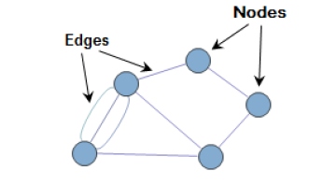
Image via http://semanticommunity.info/AOL_Government/Social_Media_-_Six_Degrees_of_Separation_and_Now_Even_Less

Types of Graphs
Undirected graph
When the relationship is always valid in both directions, then it is called undirected graph. If Dave is friends with Raj on Facebook, then Raj is also friends with Dave.

Directed graph
When the relationship may not be valid in both directions (connecting nodes), then it is called a directed graph. If Bill is following Steve on Twitter and Steve is not following Bill, the relationship is directed.

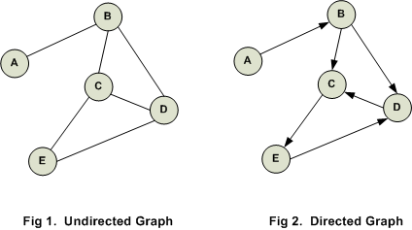
Image via http://www.codediesel.com/wp-content/uploads/2012/02/d-graph1.gif

Weighted network
A network in which the edges between nodes have weights (corresponding to, e.g., the strength of a relationship) assigned to them.

Unweighted network
A network in which the edges between nodes do not have weights assigned to them.
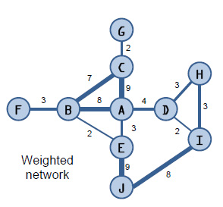
Image via http://blogs.sas.com/content/sascom/files/2011/10/weighted-network2.jpg

Single-mode graph
A type of graph in which all nodes belong to the same category. For example, in a graph of Facebook friends, each node is a person.

Multimode graph
A type of graph in which all nodes are not of same type. For example, a graph that includes both “buyers” and “sellers” is a multimode (or two-mode, or bimodal) graph.

Ego network
When you perform ego network analysis, you select a focal node (an “ego”) and determine its connections to other nodes (which are called “alters”). Each ego is treated as its own case.

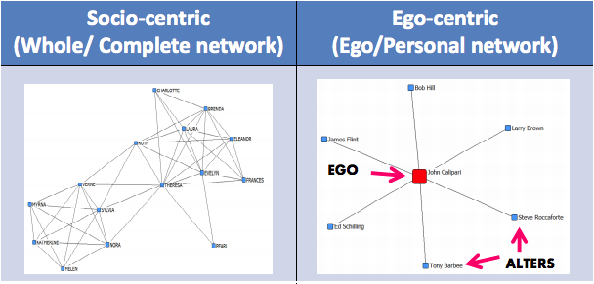
Image via http://www.analytictech.com/e-net/pdwhandout.pdf

Measures of Graphs or Nodes
Size
A measure of the number of actors (nodes) in a complete or egocentric network.

Density
The number of ties in the network reported as a fraction of the total possible number of ties.

Reciprocity
The proportion of mutual ties in a network.

Distance
The number of “steps” between any two actors in a network.

Clustering coefficient
A measure of a network’s actors’ tendency to “group together” into pockets of dense connectivity.
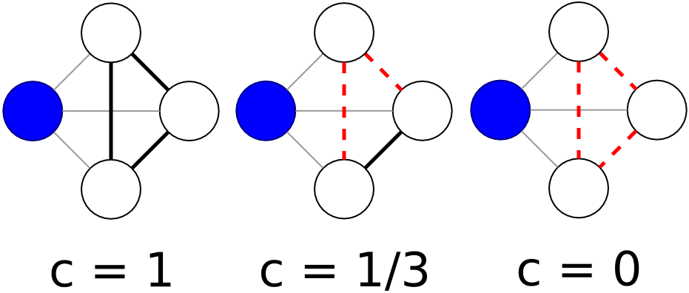
In the first image, the blue node has a clustering coefficient of one, because all possible connections among its neighboring nodes have been realized. In the second image, only one of the possible connections has been realized — so the blue node has a clustering coefficient of 1/3. In the third image, none of the neighboring nodes are connected, so the blue node has a clustering coefficient of 0. Image via Wikipedia.

Centrality
There are multiple ways to determine a node’s importance, or centrality. The measure you use depends on how you define centrality. Several of these measures are:

Degree centrality
An important node is involved in large number of interactions. The number of edges connected with a particular node.

Eigenvector centrality
An important node is connected to important neighbors. This is a measure of influence of a given node in the whole network. The notion is how well-connected a given node is with other well connected nodes in the network. This is how, for example, Google determines page rank.

Betweenness centrality
An important node lies on a high proportion of paths between other nodes in the network. Model based on communication flow. A person who lies on communication paths can control communication flow, and is thus important.

Closeness centrality
An important node is typically “close” to, and can communicate quickly with, the other nodes in the network. Length of the average shortest path between a given node and all other nodes in a graph.

